BAG CAGE INSTALLATION
CENTRE CAGE
KCB01

Please refer to the pictures in the Installation Demo area for reference at www.mikeyeeoutfitting.com

NOTE:
-For ease of installation and future changes to boating and gear needs (tripping), the centre cage is installed in 2 sections with the centre thwart
(Yoke) acting as the break point for the cage.
-Components of the KCB01 Bag cage kit is used for either complete centre cage or 2 end cages, but not both. To have the boat fully bagged
with 2 end cages and centre cage, you will require 2 bag cage kits.

Mark the length and location or the centre bag (average bag length is 50”) (pic 1L) and drill holes 4” apart.

At the ends of the cage, map out the cage anchors (pic 1M), this can also be done after the cage has been strung

Starting from the end closest to seat, string the cage towards the centre thwart (pics 1R, 2L)

Back at the start point (seat end) make a loop (pic 2M) and tighten cage string towards the centre thwart (pic 2R)

At the thwart, double back to second last hole and insert (pic 3L), tie off by using 3 half hitches to secure cage strings (pics 3M, 3R)

Tie off your last 3 loops with the centre 2 approx 8-10 from the gunwale (pic4L), complete cage as in steps above (pic 4M)

Repeat procedure for other half of cage (pics 4R, 5L)

Run secondary lines (to reduce gaps in cage) from the centre 2 loops end to end (pic 5M) ( run line under cage string)

Run centre webbing from end to end (pics 5R, 6L) leave 24-30” slack on both ends ( run webbing under cage string)

Top of the cage is now complete (pics 6M, 6R)

With the cord in place take two bag rings and one releasable bag ring  Place the releasable bag ring in the center of the boat at the end of the cord and mark it  Take the other two rings and space them evenly between the center ring and the sides of the boat, mark them  Your bag cage is now mapped out and ready to glue  When looking at the cage the bag rings and the cord loops should be alternately spaced  Wipe down the boat surface area and the patch with acetone  Apply a thin layer of glue to both surfaces and let dry for approx 10-15 mins | 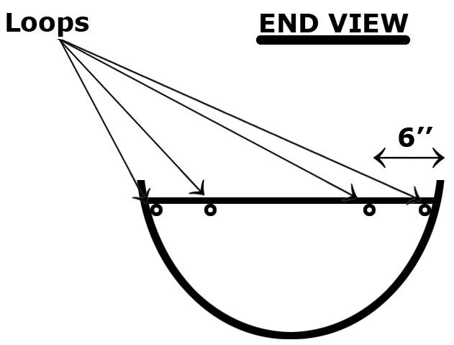

Re-heat with hair dryer or heat gun to re-activate the glue (if using a heat gun, be careful not to over heat)

Apply the patches and rub down

It will take approx 1-2 hours for the glue to set and 8 hrs for a full cure

After patches are set, take a length of cord and tie it off to one of the loops at the gunwale end, run it through one of the bag rings, then up to the next loop, down to the center ring, up to the next loop, etc. till you reach the other gunwale loop and tie it off
When done, it should resemble a “w”
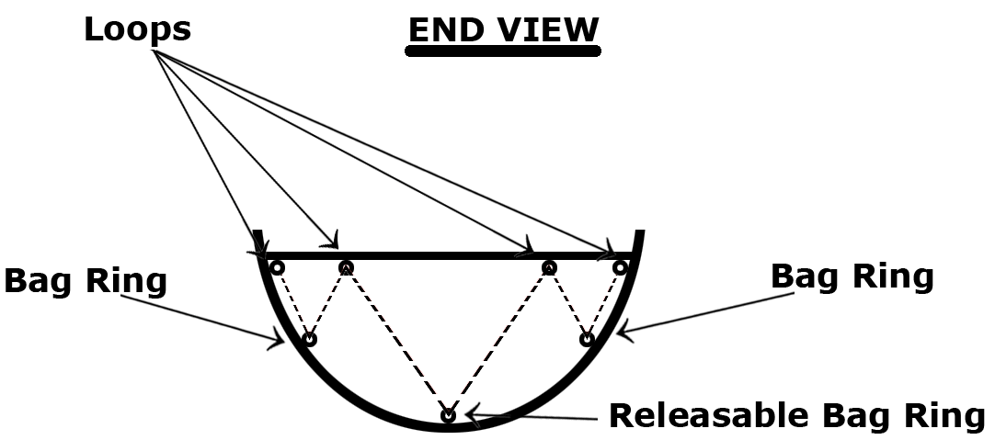

For more detailed pictures, go to “Top Loader” bag cage section

Enjoy.
Mike Yee
mikeyee@sympatico.ca

