BAG CAGE INSTALLATION
END CAGES
KCB01

Please refer to the pictures in the Installation Demo area for reference at www.mikeyeeoutfitting.com

Mark off on the gunwales to where the air bags will fit in the boat (pic 1L)

With a pencil mark every 4 inches from the ends of the boat to the length of the air bag (gunwale mark) (pic 3L)

At this point you can decide whether you will drill through the hull or add clips to the gunwales for your cord.

Remove the factory grab loop (If supplied) and run the first v-line and the webbing loop (pic 1M,1R)
Then replace the grab loop with the 1” webbing grab loop. We find this is the most comfortable material for carrying the full weight of the boat.
Using 21” cord supplied with grab loop, tie loop around the existing grab loop holes. Attach 1” webbing to this loop (pic 2L). Measure to end of bag length and leave extra 36” and cut (pic 2M)

Run cord through the ends of the boat (pic 3L)

At the paddler end of the cage, tie off a loop (pic 2R) and tighten up cage towards the end (pic 3L)

At the end of the cage, double back onto the second last hole and insert thru boat (pic 3M, 4M), tie off with 3 half hitches (pic 3R)
top bag cage strings should now be tight and secure.

At the paddler end of the cage tie off 3 more loops, one on each side of the boat against the gunwale and two more approx 6 inches towards the center of the boat (pic 4L), finish off cage as in step above (pic 4M)

Attach the v-line to loops 2 & 3 (pic 4R). Make sure to run the lines under the bag cage strings except for the last run to give support.

Attach 1” webbing to the cage strings (pic 5L), run webbing under the cage strings as above

With the cord in place take two bag rings and one releasable bag ring  Place the releasable bag ring in the center of the boat at the end of the cord and mark it  Take the other two rings and space them evenly between the center ring and the sides of the boat, mark them  Your bag cage is now mapped out and ready to glue  When looking at the cage the bag rings and the cord loops should be alternately spaced (pic 5M)  Wipe down the boat surface area and the patch with acetone  Apply a thin layer of glue to both surfaces and let dry for approx 10-15 mins | 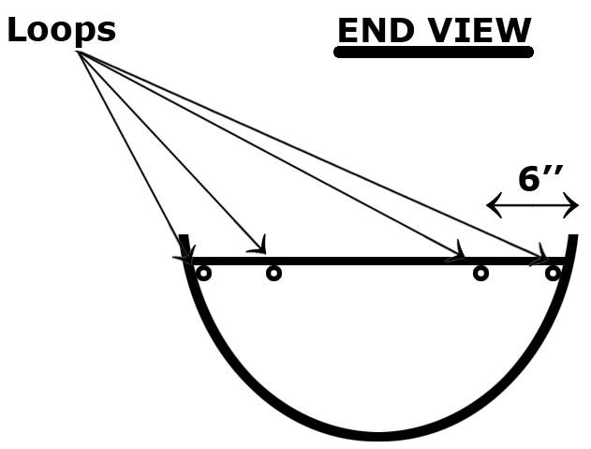

Re-heat with hair dryer or heat gun to re-activate the glue (if using a heat gun, be careful not to over heat)

Apply the patches and rub down

It will take approx 1-2 hours for the glue to set and 8 hrs for a full cure

After patches are set, take a length of cord and tie it off to one of the loops at the gunwale end, run it through one of the bag rings, then up to the next loop, down to the center ring, up to the next loop, etc. till you reach the other gunwale loop and tie it off
When done, it should resemble a “w”
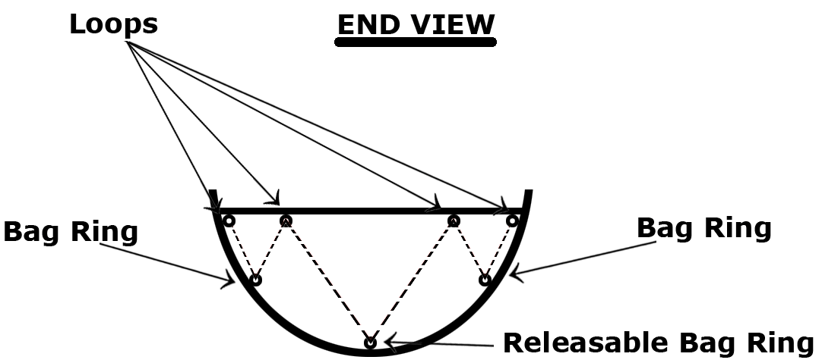

For more detailed pictures, go to “Top Loader” bag cage section

Enjoy.
Mike Yee
mikeyee@sympatico.ca

